Fullname: ..............................................  Class: 4 ......  Date: .................................... |  | BÀI KIỂM TRA CUỐI HỌC KÌ I  MÔN TIẾNG ANH LỚP 4  NĂM HỌC: 2022 - 2023  (Thời gian làm bài: 40 phút)
MARK | COMMENT  ..........................................................................................................................................................................................................

PART 1: LISTENING
Question 1: Listen and number (1pt)
A. | 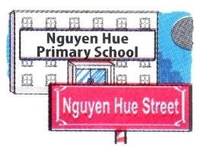  B. | 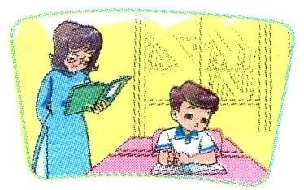  C. | D.
Question 2: Listen and tick (1pt)
1 |  |  | 2 | 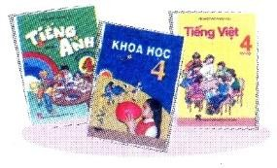
3 | 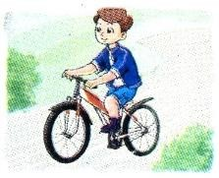 |  | 4
Question 3: Listen and tick or cross (1pt
 |  |  | 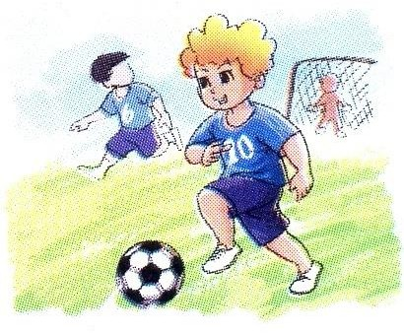
1. | 2. | 3. | 4.

PART 2: READING AND WRITING

Question 4: Look and write a missing word (1pt)
Dear penfriend,
Hi! My name is Mai. I’m nine years old. I’m a student in Class 4B at Ngoc Ky Primary School. I’m Vietnamese. I like collecting dolls. I have a lot of dolls. I don’t like swimming. This is a photo of me. I really want a penfriend.
Please write to me: mai@english.com.vn.
1. Mai is ...................................................
2. She is ..................................... at Ngoc Ky Primary School.
3. She likes ...................................... dolls.
4. She .......................... like swimming.
Question 5: Read and match (1pt)
1. Where are you from, Akiko? |  | a. It’s on the second of September.
2. What are Linda and Mai doing? |  | b. I have Maths, IT and English.
3. When’s your birthday? |  | c. They’re skipping.
4. What subjects do you have today? |  | d. I’m from Japan.
Question 6: Read and complete (1pt)
playing doing flying play
Peter: I have a new kite. Let’s fly it.
Nam: I’m sorry but I don’t like (1) …………………. kites.
Peter: What do you like (2) ………………….?
Nam: I like (3) …………………. chess.
Peter: OK, let’s (4) ………………….
Question 7: Read and write (1pt)
Phong is a new pupil in Class 4D at Nguyen Du Primary School. It is a big school in Hoan Kiem District. His new classroom is large. There are eighteen desks and thirty-six chairs. There is a big black board on the wall. His favourite subjects are Vietnamese and Maths. He likes English, too. He can sing many English songs well. In his free time, he often goes to the Music Club.
1. What class is Phong in ? ................................................................................
2. Is his new school big ? ................................................................................
3. What are his favourite subjects ? ................................................................................
4. What does he do in his free time ?
.........................................................................................................................
Question 8: Put the words in order (1pt)
1. What / the date / is /today ? ..................................................................................
2. It / Nguyen Du / is in /Street. ..................................................................................
3. collecting / I / stamps. /like ..................................................................................
4. nationality / What / you ?/are ..................................................................................

PART 3: SPEAKING

Question 9: Getting to know each other (1pt):
1. What’s your name? | 2. What class are you in?
3. What do you likke doing? | 4. How old are you?

Question 10: Discuss the picture (1pt):

1. How many boys/girls are there?

2. What are the boys/girls doing?

ANSWER KEYS – GRADE 4
PART 1: LISTENING

Question 1: Listen and number (1pt):
a. 1 b. 4 c. 3 d. 2

Question 2: Listen and tick (1pt):
1. a 2. b 3. a 4. a

Question 3: Listen and write ✓(tick) or ✗ (cross) (1pt):
1. ✗ 2. ✓ 3. ✓ 4. ✗

PART 2: READING AND WRITING

Question 4: Look and write a missing word (1pt):

1. nine years old 2. a student in Class 4B 3. collecting 4. doesn’t

Question 5: Read and match (1pt):
a. 3 b. 4 c. 2 d. 1
Question 6: Read and complete (1pt):
1. flying 2. doing 3. playing 4. play
Question 7: Read and write (1pt):
1. He’s in Class 4D 2. Yes, it is
3. They’re Vietnamese, Maths and English. 4. He often goes to the Music Club.
Question 8: Put the words in order (1pt):
1. What is the date today? 2. My school is in Nguyen Du Street.
3. I like collecting stamps. 4. What nationality are you?

PART 3: SPEAKING
Question 9: Getting to know each other (1pt):
1. My name’s ………… 2. I’m ………… (years old).
3. I’m in Class ………… 4. I like …………

Question 10: Discuss the picture (1pt):
1. There are two boys. 2. There is one girl.
3. They are at home. 4. They’re watching TV.

MA TRẬN ĐỀ KIỂM TRA CUỐI HỌC KỲ 1 LỚP 4

Kỹ năng | Nhiệm vụ đánh giá/kiến thức cần đánh giá | Mức/Điểm |  |  |  | Tổng số câu, số điểm, tỷ lệ %
LISTENING |  | M1 | M2 | M3 | M4 | 12 câu  3 điểm  33 %
 | Q1. Listen and number | 1  0.25 | 2  0.5 | 1  0.25
 | Q2. Listen and tick |  | 2  0.5 | 2  0.25
 | Q3. Listen and tick or cross |  | 1  0.25 | 2  0.25 | 1  0.25
READING  WRITING | Q4. Look and write a missing word | 1  0,25 | 3  0,75 |  |  | 20 câu  5 điểm  50%
 | Q5. Read and match |  | 2  0,5 | 1  0.25 | 1  0.25
 | Q6. Read and complete | 1  0.25 | 1  0.25 | 2  0.5
 | Q7. Look and write |  | 2  0,5 | 2  0,5
 | Q8. Order the words | 1  0.25 | 1  0.25 | 1  0.25 | 1  0.25
SPEAKING | Interview |  | 2  0, 5 | 2  0,5 |  | 8câu  2 điểm  17 %
 | Describing a picture | 1  0,25 | 2  0,5 | 2  0,5 | 1  0,25
Tổng |  | 5 | 17 | 14 | 4 | 40 câu -  10 điểm  100%

