Fullname: ...............................................  Class: 5 ......  Date: .................................... |  | BÀI KIỂM TRA CUỐI HỌC KÌ I  MÔN TIẾNG ANH LỚP 5  NĂM HỌC: 2022 - 2023  (Thời gian làm bài: 40 phút)
MARK | COMMENT  ......................................................................................................................................................................................................................

PART 1: LISTENING
Question 1: Listen and number (1pt):
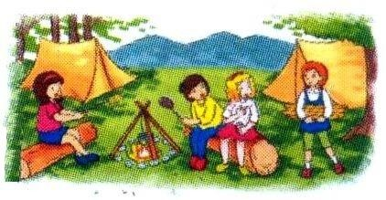 | 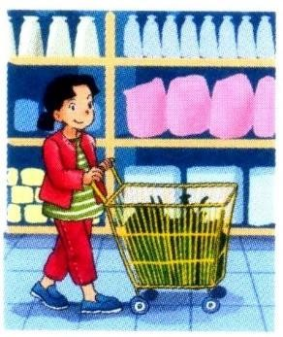
a. | b. | c. | d.
Question 2: Listen and tick (0.5pt):
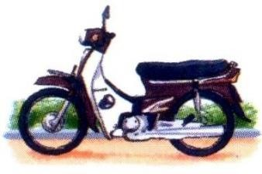
1. |  | 2.

Question 3: Listen and tick or cross (0.5pt):
1. | 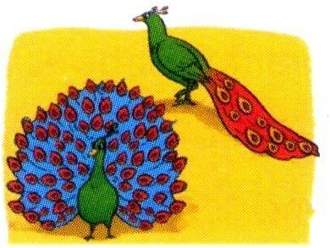 | 2.

Question 4: Listen and write a missing word (0.5pt):
1. What are you reading, Quan ?  .................... and the Magic Lamp. | 2. How often do you have ..................... ?  I have it four times a week.

PART 2: READING AND WRITING
Question 5: Read and match (1pt):
1. How many lesson so you have today?  2. How did you get there?  3. What’s your address, Mai?  4. What are the crocodiles like? |  | a. It’s 97, Hai Ba Trung Street.  b. They are very scary.  c. I went by bus.  d. I have English, Art and Music.
Question 6: Read and complete (1pt)
swim | weekend | islands | football
Mai: What will you do this (1) ?
Linda: I’ll go for a picnic.
Mai: Where will you go?
Linda: I’ll go to Nha Trang.
Mai: What will you do there?
Linda: I’ll play (2) ……………… on the beach and (3) in the sea.
Mai: Will you visit the (4) ?
Linda: Yes, I will.
Question 7: Read and tick True (T) or False (F) (1pt):
Last weekend, I went to the zoo with my parents. We saw a lot of animals. First, we saw the elephants. They were very big. They moved slowly and quietly. Then we saw the kangaroos. I enjoyed watching them because they jumped very high and ran quickly. In the end, we went to see the monkeys. They looked funny. They swung from tree to tree all the time. They jumped up and down on the trees very quickly. We had a really good time.
 | T | F
1. I went to the zoo with my classmates.
2. The elephants were very big and moved quietly.
3. The kagaroos jumped very high and ran slowly.
4. We had a wonderful time.
Question 8: Look and write (1pt)
1. | A: Did you enjoy the  party?  B: Yes, …………… | 2. | A: How often do you  ........................ ?  B: Once a week.
3. | A: Where will you be  this weekend ?  B: I think I’ll be  ……………… | 4. | A: What’s the  ....................... like?  B: It’s far and quiet.
Question 9: Put the words in order (1pt)
1. I /tigers./lots/of /saw .................................................................................
2. Why/you/learn/do/English? .................................................................................
3. The/ate/pandas/slowly. .................................................................................
4. When/be?/will/Teachers’Day .................................................................................

PART 3: SPEAKING

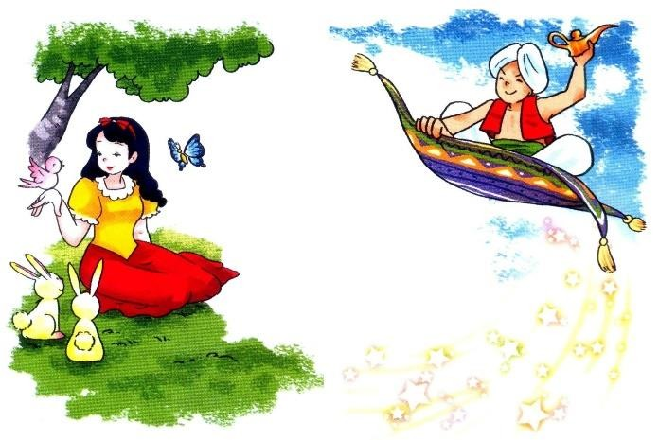
Question 10: Getting to know each other (1pt):
1. What’s your name? How do you spell your name?
2. What day is it today?

Question 11: Describing the picture (1.5pt):

1. Who’s the girl/ boy?

2. What’s the girl/ boy like?

ANSWER KEYS – GRADE 5
PART 1: LISTENING

Question 1: Listen and number (1pt):
a. 4 b. 1 c. 2 d. 3

Question 2: Listen and tick (0.5pt):
  - b 2. b

Question 3: Listen and tick or cross (0.5pt):
1. 2.

Question 4: Listen and write a missing word (0.5pt):
1. Aladdin 2. English

PART 2: READING AND WRITING

Question 5: Read and match (1pt):
a. 3 b. 4 c. 2 d. 1

Question 6: Read and complete (1pt):
1. weekend 2. football 3. swim 4. Islands

Question 7: Read and tick True (T) or False (F) (1.pt):
1. F 2. T 3. F 4. T

Question 8: Look and write (1pt):
1. I did 2. go fishing 3. at school 4. Village

Question 9: Put the words in order (1pt):
1. I saw lots of tigers. 2. Why do you learn English?
3. The pandas ate slowly. 4. When will Teachers’ Day be?

PART 3: SPEAKING

Question 10: Getting to know each other (1pt):
1. My name’s ………… 2. That’s .............
3. It’s ........................

Question 11: Describing the picture (1.5pt):
1. She’s Cinderella. 2. She’s beautiful and kind.
3. He’s Aladdin. 4. He’s clever and generous.

MA TRẬN ĐỀ KIỂM TRA CUỐI HỌC KỲ 1 LỚP 5

Kỹ năng | Nhiệm vụ đánh giá/kiến thức cần đánh giá | Mức/Điểm |  |  |  | Tổng số câu, số điểm, tỷ lệ %
LISTENING |  | M1 | M2 | M3 | M4 | 10 câu  2,5 điểm  25%
 | Q1. Listen and number | 1  0.25 | 2  0.5 | 1  0.25
 | Q2. Listen and tick |  | 1  0.25 | 1  0.25
 | Q3. Listen and tick or cross |  | 1  0.25 | 1  0.25
 | Q4. Listen and write a missing word |  |  | 1  0.25 | 1  0.25
READING  WRITING | Q5. Read and match | 1  0,25 | 3  0,75 |  |  | 20 câu  5 điểm  50%
 | Q6. Read and complete |  | 2  0,5 | 1  0.25 | 1  0.25
 | Q7. Read and tick True or False | 1  0.25 | 1  0.25 | 2  0.5
 | Q8. Look and write |  | 2  0,5 | 2  0,5
 | Q9. Order the words | 1  0.25 | 1  0.25 | 1  0.25 | 1  0.25
SPEAKING | Interview |  | 2  0, 5 | 2  0,5 |  | 10câu  2.5 điểm  25%
 | Describing a picture | 1  0,25 | 2  0,5 | 2  0,5 | 1  0,25
Tổng |  | 5 | 17 | 14 | 4 | 40 câu -  10 điểm  100%

